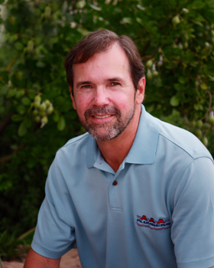  Steve Park  Office: 713.462.4753  Fax: 713.462.1209  Cell: 713.249.4182 |  Aquasolve Chemical Company  H.P. (Paul) Young  Office: 713.995.5181  Fax: 713.995.  Cell: 713.828.7415
  Andrea Winans  Office: 281.578.9177  Fax: 281.578.9539  Cell: 832.275.9694 | 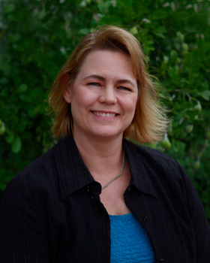  Michelle Bridges-Pahl  Office: 281.933.3991  Fax: 281.530.2859  Cell: 713.516.1901
Coinmach  Daniel Kittrell  Office: 713.675.4000  Fax: 713.675.5037  Cell: 832.877.8528 | 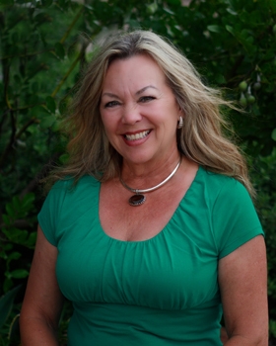  Arrie Colca  Office: 713.956.1395  Fax: 713.477.7911  Cell: 713.725.0309
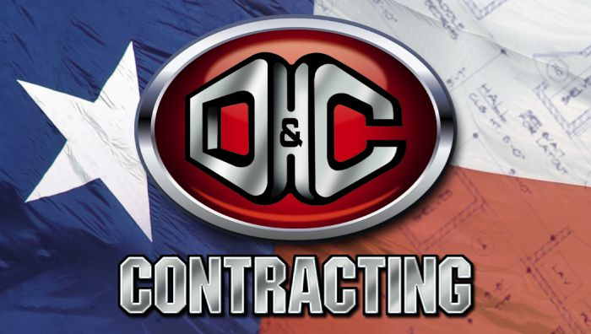  Lisa Grimes  Office: 713.460.9394  Fax: 713.460.8408  Cell: 281.780.0160 |   Gerald Colca  Office: 713.562.8447  Fax:  Cell:
  Alan Jones  Office: 713.270.4438  Fax: 713.772.8180  Cell: 713.305.0217 | J and L  Brenda Nite  Office: 281.403.6733  Fax: 281.403.6711  Cell: 713.829.1954
  Dean O’Kelley  Office: 713.961.7666  Fax: 713.961.3140  Cell: 832.606.2854 |   John Balusek  Office: 281.494.3232  Fax: 281.494.3285  Cell: 281.935.7187
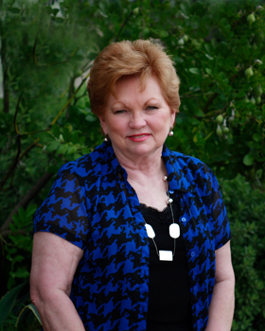  Barbara Brett  Office:  Fax:  Cell: |   Beth Varney  Office: 713.461.2188  Fax: 713.461.8884  Cell: 281.330.2646
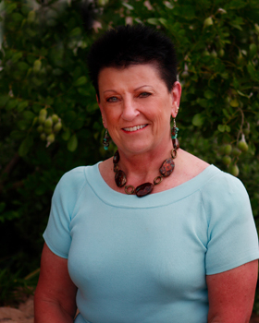  Peggy Charles  Office:  Fax:  Cell: | 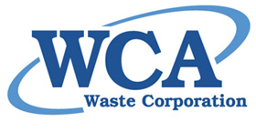  Erin Nicholas  Office:  Fax:  Cell: 832.381.6533
HAANG Flyer 1

